Pre-Show Information
Young Vic presents
Further than the Furthest Thing
Written by Zinnie Harris
Directed by Jennifer Tang

This document contains detailed information about the show in order to describe what you should expect when attending.
This includes information about the content warnings, plot, the space, lighting and sound, audience participation, and further access information.
All of the information in this document was correct at the time of publishing. More information will be available closer to the time of performance.
Please note that by discussing the content of the show, the below information will contain key plot points and descriptions of what happens in the performance.
If you would like to receive elements of this information but avoid these spoilers, please do not read the sections at the end of this document ‘Show Information’ and ‘Show Synopsis’.
If you have any questions, please do not hesitate to contact our Box Office team:
E-mail: boxoffice@youngvic.org
Phone number: 020 7922 2922

The Auditorium
Further than the Furthest Thing
This show will take place in our main auditorium, which is the larger of our three performance spaces.
For this performance, the space will be in an ‘in the round’ arrangement, meaning the seats are arranged on four sides of the stage (see below). The maximum capacity is 417.
Access to the main auditorium is via the upstairs (rows J – K) and downstairs (rows A – D) via the main doors. Our ushers are on hand to help you, they wear red t-shirts and jumpers with our logo.
Please arrive at the Young Vic with your ticket ready on your phone or have it printed before you enter or you can collect from box office.

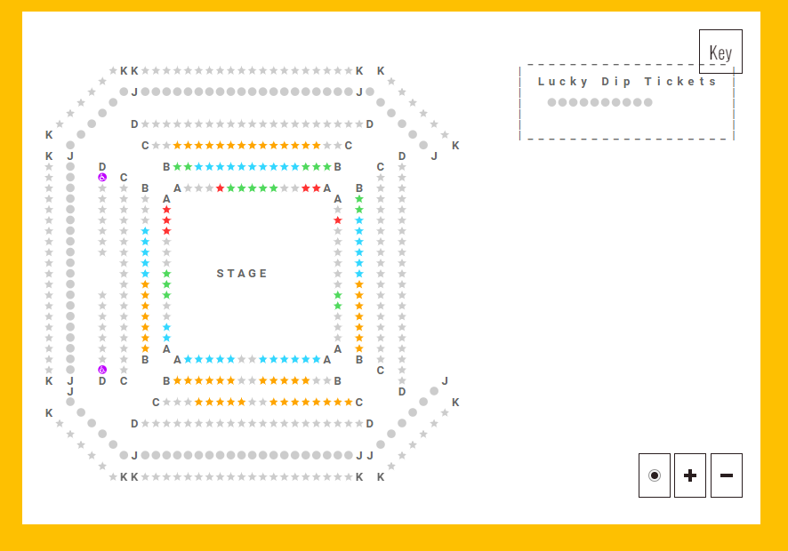

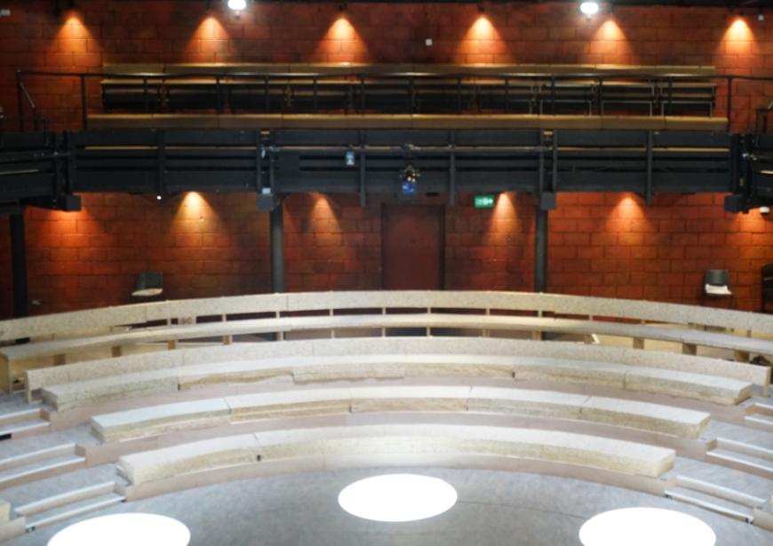
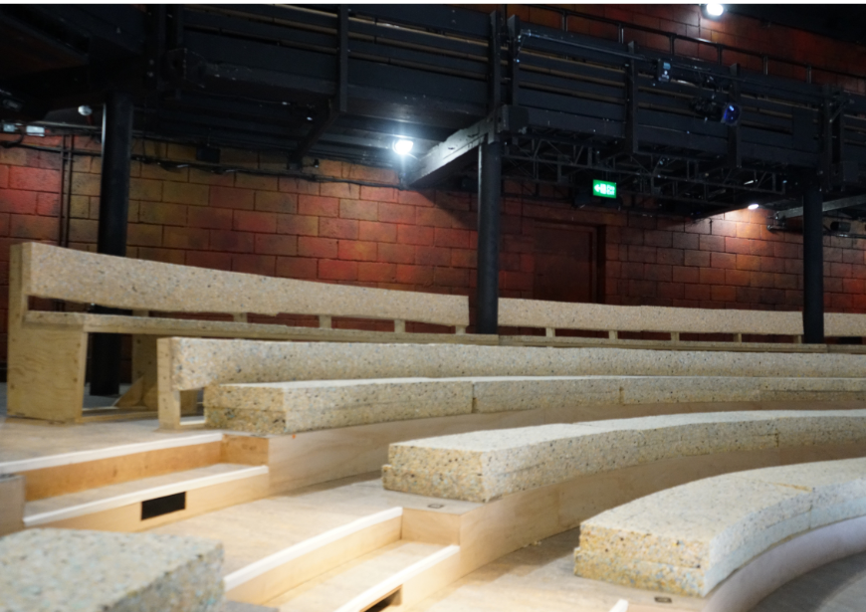
Facilities:
There are toilets located on the ground and first floor at the Young Vic, via The Cut Bar. We have gender-neutral and accessible/baby changing toilets. Sanitary bins are available in all. All indoor venues will also be accessible with lifts & ramps and toilet provided.
Assistance Dogs:
Assistance dogs are always welcome at the Young Vic, if you are planning a visit please let us know in advance which performance you will be attending by calling our box office on 020 7922 2922 or e-mailing boxoffice@youngvic.org and we will be happy to look after your dog during the show.

Access for all:
For full information about or access measures, please visit our Access for all page, on our website here: www.youngvic.org/visit-us/access-for-all
Show Information:
Content Warnings: This show contains strong language, xenophobia, and depictions of pregnancy and infanticide. The show contains references to sexual violence, mental illness, self-harm, and death.
Sound: This show has loud sound effects and moments of loud music.
Lighting: Moments of flashing lights, flashing video effects, fog and haze, and full blackout.
Stage: This show has performers in the audience throughout, and involves the handling of food and drink.

Show Synopsis:
Act I
Act 1, Scene 1:
In an opening scene with no dialogue, Bill disrobes and swims out into a mountain lake on the island, but becomes afraid of a terrible rumbling noise and swims back in, nearly drowning in the process.
Act 1, Scene 2:
The scene begins with Francis, the first person to leave the island for a long time, returning home to his Aunt Mill. Mill is wary of him, and accusatorily tells him of everything he has missed on the island. There is an awkwardness between them, but eventually Mill breaks down and embraces Francis. Francis’s uncle Bill comes in to warn Mill about the ominous noise he heard in the lake. Mill doesn’t believe Bill, and is frustrated by his failure to pay attention to Francis upon his return. Francis leaves to get his bag from the beach, claiming he has a surprise for his aunt and uncle.
Mill confronts Bill about not being affectionate enough towards Francis, and Bill reluctantly agrees to delay his investigation of the lake and stay for a meal. Mill explains that she took three penguin eggs she found to make a special meal to celebrate Francis’s return, and remarks that they haven’t eaten penguin eggs since Bill’s father died. Bill disapproves of her actions, arguing that taking the eggs was bad luck. As they reminisce and cook, they smash two of the eggs. Bill tries to console her, but Mill cries thinking of the penguin mother who will not find her eggs, reflecting on how she will never be a mother herself.
Francis returns with his surprise, a factory owner from Cape Town named Mr. Hansen who manufactures jars and containers. Mill defends island life to Mr. Hansen, who appears cold and condescending. Mr. Hansen makes a glass jar appear from his egg shells, and then upon Mill’s request performs two more acts of magic, transforming the jar into an egg and then coins. After his departure, Francis reveals their plan to build a new factory on the island in order to obtain crawfish to jar.
Act 1, Scene 3:
Francis goes to the beach to see Rebecca, who is bathing in the sea. He asks her if she missed him, but then she steps out of the sea and reveals to him that she is pregnant. Rebecca is bitter that Francis left despite her asking him to stay. Francis reveals how badly he has been treated by the people he met in England who mocked him for his provincial clothes and speech, confessing that he cut himself every time he failed to fit in. He confesses his love to Rebecca as she leaves, but she does not respond.
Act 1, Scene 4:
In the middle of the night, Bill is unable to sleep and is dividing potatoes into piles for his family members. Mill comes downstairs and asks what he is doing, and he explains he is making his will. Upon further probing from Mill, Bill confesses that he has been deeply unsettled by the disruption in the water and his experience of almost drowning that morning. He insists he was saved and warned of coming danger by a number of deceased Old Hands. Mill worries that Bill is going crazy and asks him to ignore what he has seen. Bill alludes to something like this having happened once before.
Francis enters, and Mill goes to bed, asking Francis to look after his uncle. Bill awkwardly gives Francis his share of the potatoes, and then begins packing the rest up in preparation for bed. Francis asks Bill about Rebecca, and is angry with his uncle for not telling him she was pregnant. Bill warns Francis not to trust Mr. Hansen, insisting the factory is a bad idea and explaining that he could use his sway to discourage others in the village from agreeing to the plan. Francis argues the island should accept change and accuses his uncle of hypocrisy, pointing out that he didn’t seek consensus approval when he built a church and converted the town to Christianity. Bill says he will let Francis put the question to a village vote and not give any opinion if Francis will go to the mountain lake and listen. Bill then goes to bed.
Act 1, Scene 5:
Mill and Mr. Hansen meet on the beach where Rebecca is sitting. Mill tells Rebecca to move, and, when she refuses, refers to her supposed promiscuity, telling her to go flirt with sailors. Rebecca denies this, but moves. Mr. Hansen is anxious, but Mill excitedly asks him to describe the factory he and Francis plan to build on the island. She takes over parts of the description, fantasising about being a worker in the factory.
Francis and Bill arrive with the news that, despite the rest of the town supporting the factory, Francis has changed his mind and no longer wants to build it. Mill is disappointed and Mr. Hansen is angry. Bill tells Francis to explain his reasons to Mr. Hansen, implying Francis heard the same rumbling in the lake Bill heard. Frustrated, Mr. Hansen leaves, and Bill reassures Francis, telling him he did the right thing. Mill asks Francis if he saw anything strange in the lake, but Francis denies it, telling Bill he lied previously to pacify him. Francis says he can no longer live on the island and is planning to leave the next day with Mr. Hansen. Mill tells Bill to convince Francis to stay, saying that she will go with Francis if he leaves.
Act 1, Scene 6:
Bill goes to see Rebecca to tell her that Francis and Mill plan to leave the island, and confesses his fear it will lead to others leaving too. He asks Rebecca to lie to Francis and tell him she is pregnant with his child to convince him to stay. Rebecca initially refuses, but then begins to consider it. She reveals to Bill that she doesn’t want her baby and wishes someone would kill it. The scene ends with her asking Bill if he will kill her baby if she lies to Francis.
Act 1, Scene 7:
Bill returns to the lake, demanding “what are you?”, but receives no response.
Act 1, Scene 8:
Mill and Francis are in Mill and Bill’s house. Mill is getting Francis ready for his wedding to Rebecca, suggesting she has agreed to tell Francis the baby is his. A crowd has gathered outside, and Francis is confused by their presence. He leaves to look for Rebecca as she is late in arriving. Bill comes downstairs delighted, telling Mill to look at the volcanic eruption that has begun on the mountain, explaining the rumbling he has been hearing at the lake. Mill is worried about their house, and Bill reassures her that they are safe. Francis returns with news that Rebecca’s baby is coming and she has requested only Bill be with her. Bill leaves, and the scene ends with sounds of chaos caused by the erupting volcano.
Act 1, Scene 9:
Francis beats on Rebecca’s door screaming for her. Mill comes and leads him away.
Act 1, Scene 10:
Bill and Rebecca are in Rebecca’s house and are covered in blood. The two have clearly just killed Rebecca’s baby, and are both in shock. Rebecca tries comfort Bill by telling him the baby should never have been born, revealing she was sexually assaulted by a group of sailors. Bill realises the baby died unbaptised and baptises the corpse. Mill and Mr. Hansen enter, and Mr. Hansen reveals that the island has been evacuated due to the danger of the volcano, insisting they must board the ship to England immediately. Bill confesses to killing Rebecca’s baby, and insists it must be buried in the churchyard. Mr. Hansen tries to stop him, and Mill steps in saying she will lead the way. She warns Mr. Hansen to tell people the baby was born dead upon their return to the ship.
Act 1, Scene 11:
Mill, Bill, Mr. Hansen and Rebecca are in the vault below the church. Bill is digging a grave for the baby, and Mr. Hansen is worried the boat will leave without them. Mill asks Bill why he killed the baby, and Bill can’t answer, only telling Mill that he baptised the child. Mill reminds him not to tell Francis the truth about the baby’s death.
Act 2, Scene 1:
Act 2 begins in England, almost a year later, in Mr. Hansen’s jar factory. Mill comes in and demands to know when the refugees will get to return to their island. Mr. Hansen reveals that the island village has been entirely destroyed and there is no possibility of return. Mr. Hansen leaves for a meeting as Mill struggles to process the destruction of her home.
Act 2 Scene 2:
In a factory boiler room, Francis instructs Bill in his new rather dull job in Mr. Hansen’s factory. Bill is distracted thinking about his old work farming, and Francis chastises him, telling him he is lucky to have such a good job. Francis also warns Bill about the noise from the pipes, which Bill finds disorientating.
Act 2 Scene 3:
Mill and Bill sit together in their garden in England. Bill reflects on the fact that he and Mill are now British and wonders aloud about what this means. Mill insists they must see their island one last time. She tells Bill the other refugees have suggested she leads an effort to raise funds for a group to return. Bill is distracted, fascinated by the moisture in the ground.
Act 2 Scene 4:
Rebecca comes to Mr. Hansen’s factory at the end of the day looking for Francis. She tells Francis she misses him, but he coldly rejects her apology.
Act 2 Act 5:
Bill is working alone in the boiler room and jumps at a loud sound from a pipe.
Act 2 Scene 6:
Mill meets with Mr. Hansen and reveals her plan to lead a group of six refugees back to the island with a camera. Mr. Hansen tries to convince her to postpone, telling her the refugees will be getting improved housing if they stay. He insists they must begin considering themselves British, but Mill is unconvinced and leaves.
Act 2 Scene 7:
Rebecca comes to see Mill for help after she strikes a cruel reporter who was harassing and insulting her. Mill is initially annoyed but ultimately impressed and pleased with Rebecca. Francis arrives, and Mill reveals she has almost raised enough money to send six people to the island. She tries to convince Francis to go for her and Bill, but Francis refuses, arguing they will not be allowed to leave. Francis leaves, and Mill considers going to the reporters Rebecca met for help, though Rebecca is against it. Rebecca reveals that the reporters wanted to know about something dark that happened on the island long ago, before Bill converted the islanders to Christianity. Mill considers revealing this information to the reporter in exchange for help getting to the island, insisting the islanders must see it again before they can settle in England.
Act 2 Scene 8:
Mr. Hansen enters the boiler room where Bill is working. To a silent Bill, he confesses that the island isn’t really destroyed, and the lie is an elaborate cover up from the British government who want to use the island as a site for nuclear weapons testing. He blackmails Bill, threatening to tell the police that Bill killed Rebecca’s child.
Act 2 Scene 9:
Mill and Bill come out of their house to find their lawn chairs destroyed. Mill explains to Bill that she is going to tell the press about the event that transpired on the island before the baptisms in which Bill is implicated in some way, but Bill seems dazed and doesn’t engage. Bill reveals he is haunted by the noises of the pipes even outside of work, and continues to ask if they are near a river or sea. Mill tries to reassure him that he thought he was doing the right thing, but Bill is traumatised and wracked with guilt, referencing his murder of Rebecca’s baby.
Act 2 Scene 10:
Bill is at work in the boiler room, talking to the pipes about a river. They make a loud noise, and he screams back.
Act 2 Scene 11:
Mill arrives at Mr. Hansen’s office and demands he transcribe a letter to the press involved in the altercation with Rebecca. In the letter, she reveals that the event before the baptisms involved sending 17 people to the other side of the island to starve because the island had run out of food due to an external war which stopped supply ships. She reveals the idea came from Bill and that amongst those left to die was Mill’s sister, Francis’ mother. Mr. Hansen urges her not to tell the press this story. Their argument is interrupted by the arrival of Francis, who brings the knowledge that Bill has locked himself in the boiler room.
Act 2 Scene 12:
In a scene with no dialogue, Bill drowns himself in boiling water in the boiler room.
Act 2 Scene 13:
Mill and Francis are getting dressed for Bill’s funeral. Francis wonders what led to Bill’s suicide, and asks Mill to tell him what she told Mr. Hansen about the event before the baptisms, speculating the two were connected. Mill refuses, saying today is about burying Bill. Francis admits he already knows about how his mother died and leaves, acknowledging the permanent severance between him and his aunt. Mill finally lets herself break down.
Mr. Hansen enters and apologises for lying to Mill about the island. Mill reveals the islanders are now split, with some wanting to return and some wanting to stay, explaining the question will be put to a vote. Mr. Hansen reveals he envies Mill’s love for her homeland, saying there is something inexplicable about the island’s power to draw people back to it. He reassures Mill that supplies will always be sent to the island as long as he is alive.
Act 2, Scene 14:
At the docks, Francis intercepts Rebecca as she prepares to board the ship back to the island. She reveals that the islanders have all elected to return as they have accepted they will never feel a sense of belonging in England. Francis offers to come with her, but Rebecca warns him to only come if he really wants to, telling him he must choose for good between the island and England. With a final kiss to Francis, Rebecca leaves to board the ship.

More information will be available closer to the time of performance.
If you would like any further clarification or have any questions, please do get in touch with our Box Office team.
Email: boxoffice@youngvic.org
Phone number: 020 7922 2922

See you soon!
Welcome Team

