Pre-Show Information
Bengal Tiger at the Baghdad Zoo
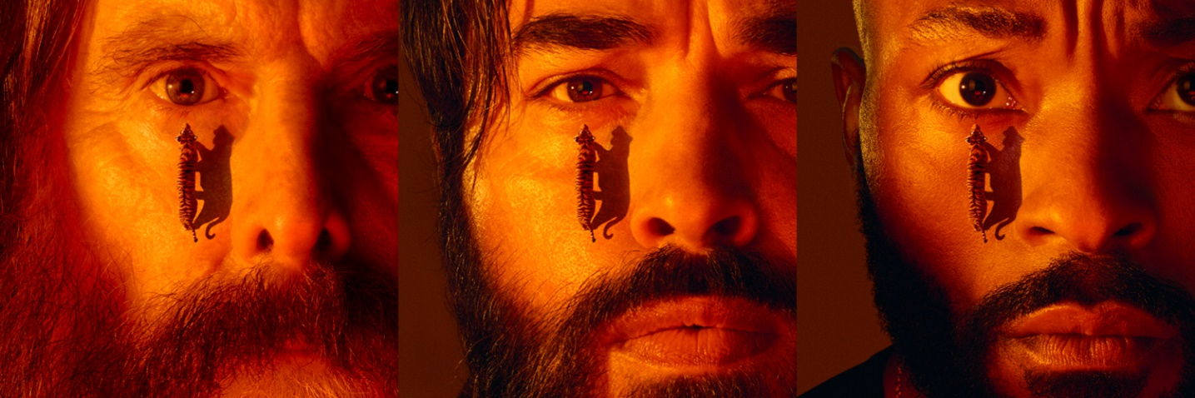

Written by Rajiv Joseph
Directed by Omar Elerian

Contents
Page 2: Introduction
Page 3: Show warnings and age guidance
Pages 4 - 5: The auditorium, including access information
Pages 6 - 9: Show summary

Introduction:
This document contains detailed information about the show in order to describe what you should expect when attending.
This includes information about the content warnings, plot, space, lighting and sound, audience participation, and further access information.
All of the information in this document was correct at the time of publishing.
More information will be available closer to the time of performance.
Please note that by discussing the content of the show, the below information will contain key plot points and descriptions of what happens in the performance.
If you would like to receive elements of this information but avoid these spoilers, please do not read the section at the end of this document entitled ‘Show Synopsis’.
If you have any questions, please do not hesitate to contact our Box Office team:
E-mail: boxoffice@youngvic.org
Phone number: 020 7922 2922

Show Warnings:

Running Time: Approx. 2 hours 30 minutes including a 20 mins interval
Content warnings:
• Replica weapons (handgun and assault rifles)
• Death and blood onstage
• Contains depictions of severed limbs and a decapitated head
• Suicide and self-harm
• War, murder, injury and violence, including violence against children
• Graphic descriptions of torture
• Strong language, including sexist, homophobic, racist and ableist slurs including use of the word 'retard'.
• Sexual content, including discussion of sexual assault and depictions of sex work

Production Warnings:
• Replica weapons and gunshots
• Very loud noises
• Blood on stage
• Smoking on stage
• Haze and smoke machines
• Blackouts
• Flashing lights (including rapid lighting to represent bullet shots and torch flashlights that may be directed toward the audience)

Age Guidance:
15+

Graphic references for some scenes contain blood in the section below:

Tom (Patrick Gibson)
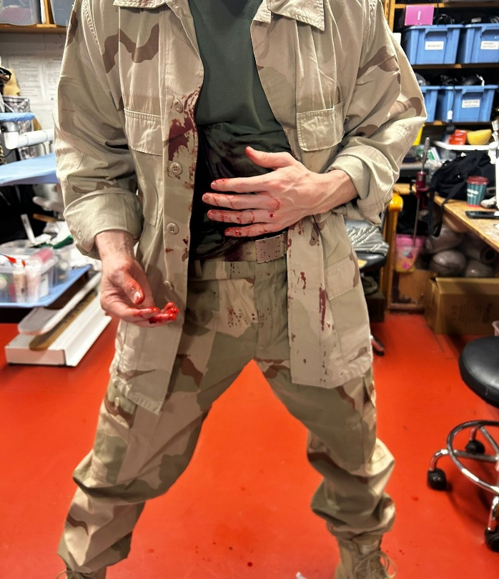
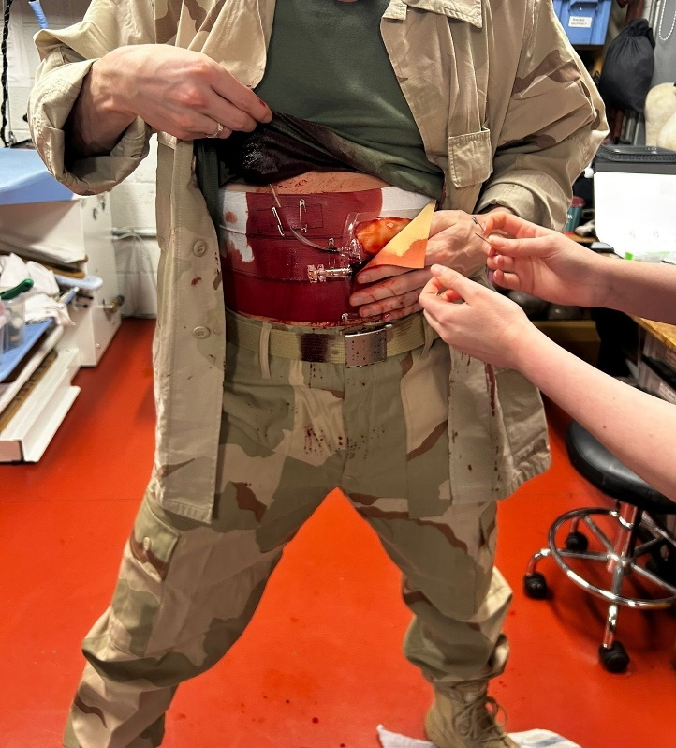
Blood - pre-show preparation and on stage

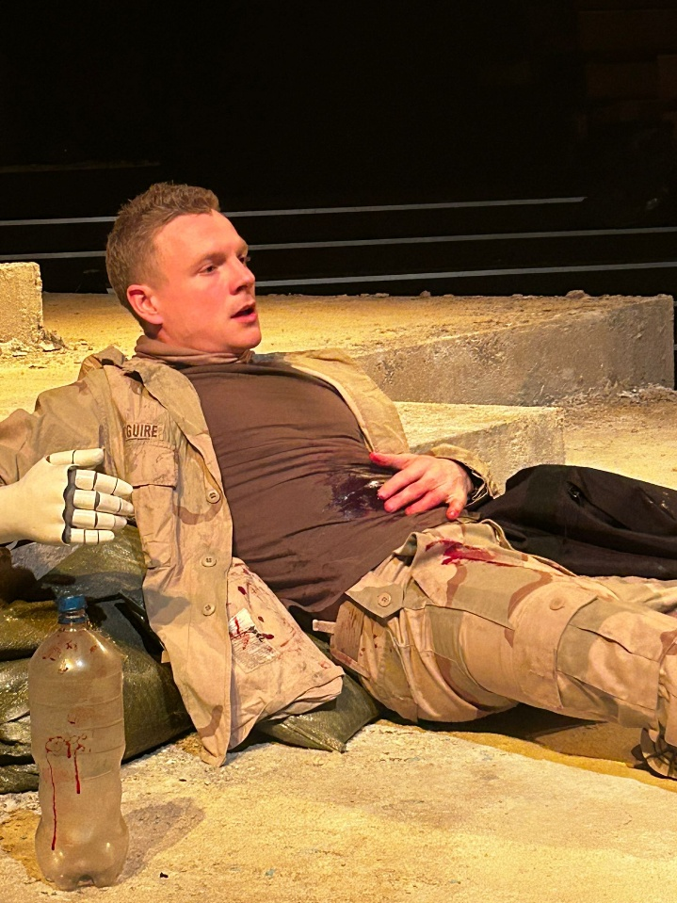

Kev (Arinzé Kene)
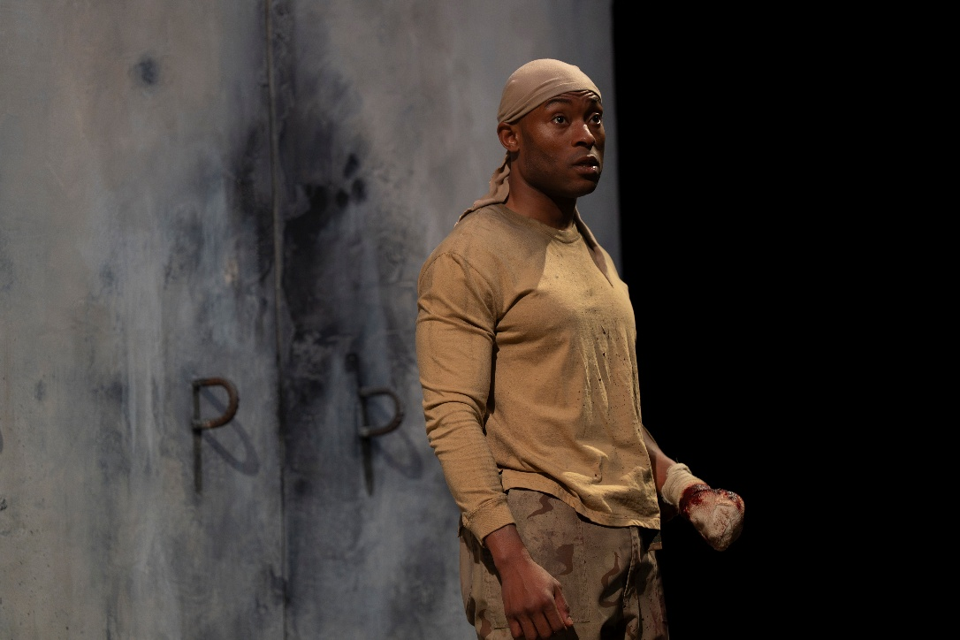
Depictions of severed limbs on stage

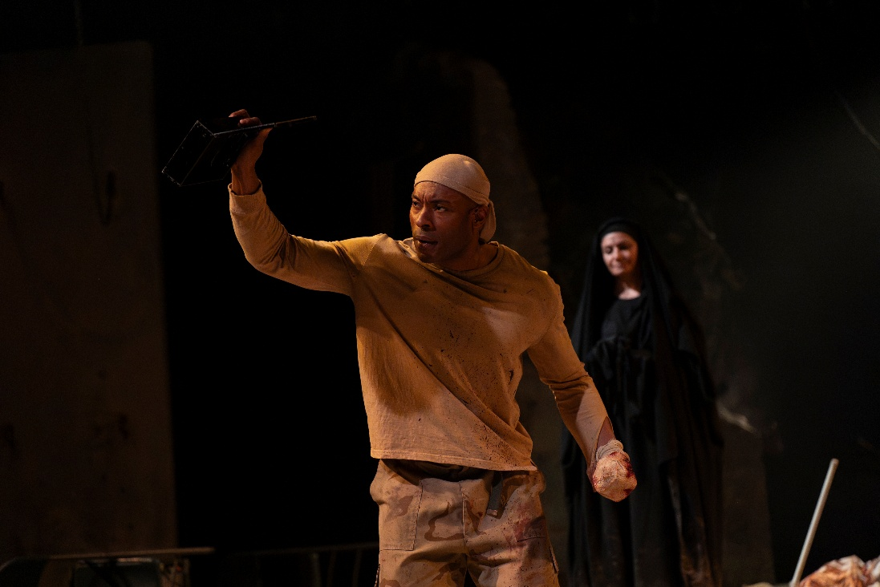

The Auditorium
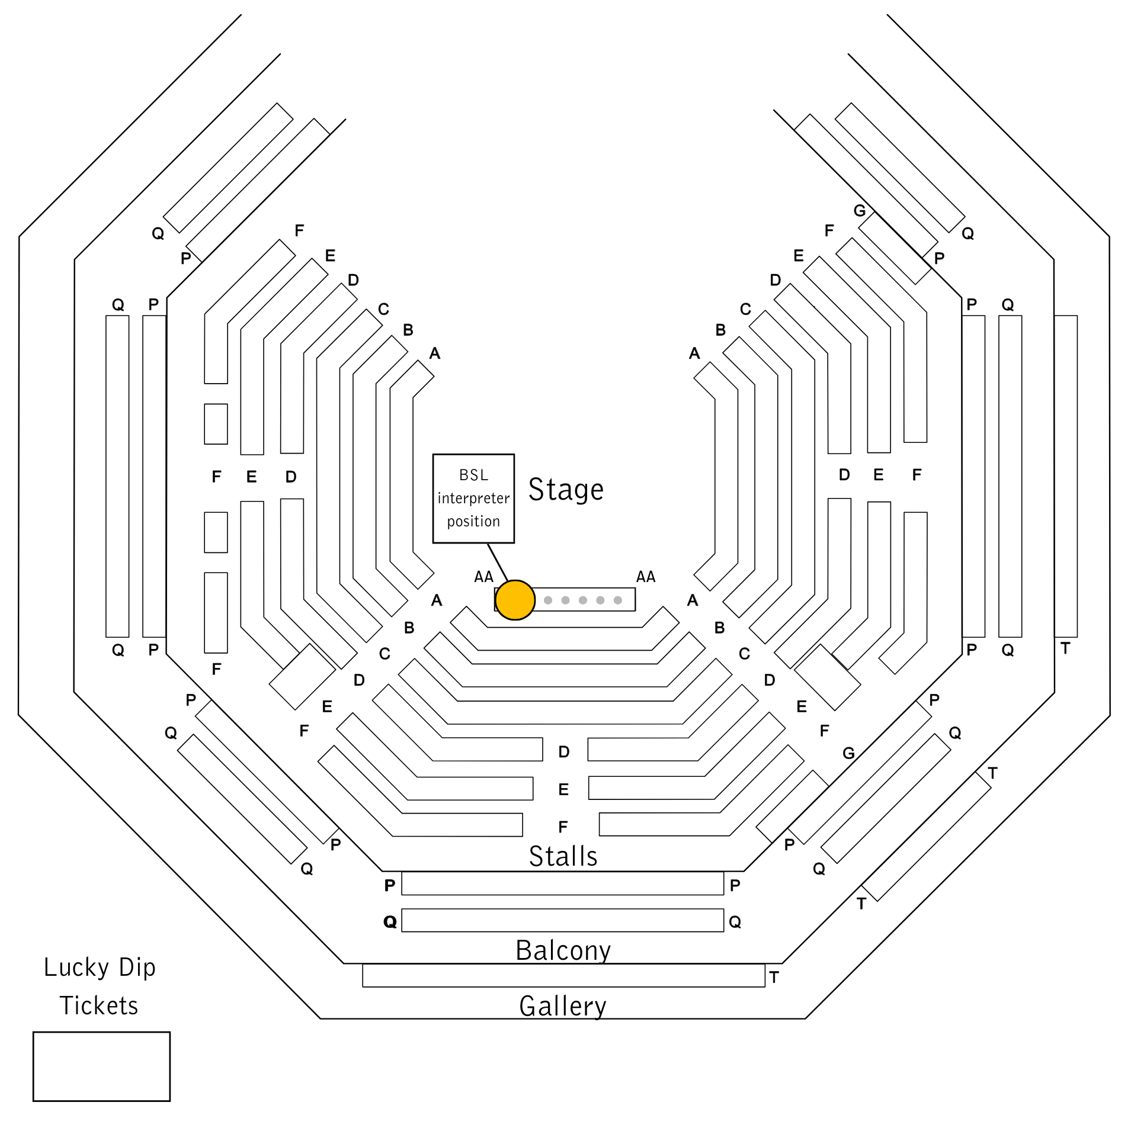

Bengal Tiger at the Baghdad Zoo
This show will take place in our main auditorium, which is the larger of our three performance spaces.
For this performance, the space will be in an “in the round” arrangement, meaning there will be seats on all sides of the auditorium facing the stage.
Access to the main auditorium is via the upstairs doors (rows K - Q) and downstairs (rows A – J) via the main doors. Rows S & T are in the gallery also accessible via the upstairs doors. Our ushers are on hand to help you, they wear red t-shirts and jumpers with our logo.
Please arrive at the Young Vic with your ticket ready on your phone. You could also print your ticket in advance of your visit, or you can collect your ticket from our Box Office.
Please click here to see a sensory map of the building.

Facilities:
There are toilets located on the ground and first floor at the Young Vic, via The Cut Bar. We have ladies and gents toilets on the ground floor and gender-neutral toilets on the first floor, as well as accessible/baby changing toilets. Sanitary bins are available in all facilities.
Building Accessibility:
All indoor venues are accessible with lifts & ramps.
Assistance Dogs:
Assistance dogs are welcome at the Young Vic. If you are planning a visit, please let us know in advance which performance you will be attending by calling our Box Office on 020 7922 2922 or e-mailing boxoffice@youngvic.org. Please note your assistance dog will need to accompany you into the auditorium.
Access for all:
For full information about our access measures, please visit our Access for all page, on our website here: www.youngvic.org/visit-us/access-for-all

Show Synopsis:
Especially violent or distressing scenes
The play begins in the Baghdad Zoo shortly after the 2003 U.S. invasion of Iraq. Two American Marines, Tom (Patrick Gibson) and Kev (Arinzé Kene), are standing guard at night. A Bengal Tiger (Peter Forbes) in a cage begins speaking directly to the audience, describing his hunger and reflecting bitterly on how he came to be trapped in the zoo. Tom and Kev talk about the war and the strange assignment of guarding zoo animals. Tom shows Kev a gold pistol which previously belonged to Saddam Hussein’s son Uday Hussein and which he took in the raid of his mansion. Tom describes how everything in the mansion was made of gold, even the toilet seat, which he has buried in a hidden location to make him rich once the war is over. The two speak crudely about their desire for sex and violence. When Tom tries to taunt the Tiger through the bars, the starving Tiger bites off Tom’s hand. Kev immediately shoots and kills the Tiger. After the Tiger dies, he continues to exist as a ghost, reflecting on how sad his life has been.
In the next scene, we meet Musa (Ammar Haj Ahmad), an Iraqi translator who is working for Kev. Kev is rude and demeaning to Musa, using racist language to try and make himself seem more in control. We find out that Tom is alive and recovering in America. Kev shows Musa the golden gun and tells Tom’s story of killing Saddam Hussein’s sons at their mansion as if it is his own. This story gets a strong reaction from Musa, which alarms Kev, causing him to reveal he is completely out of his depth with the war.
Scene 3 opens with Kev raiding an Iraqi home and Musa attending to translate. Dialogue in this scene is in both Arabic and English. Kev is violent and erratic. Halfway through, the Tiger enters. Only Kev can see him, plagued by guilt from his only killing in the war. Kev strips off his clothes, threatening to take on the Tiger, and then collapses crying. Musa takes the golden gun and leaves Kev on the ground weeping and apologising.
In scene 4, the Tiger delivers a philosophical monologue about the cruelty of humans and his confusion about why he is still here as a ghost. He suggests the pointlessness of believing in God in the face of such mindless violence.
In scene 5, Kev and Tom have re-united in hospital. Tom, who has returned to Iraq with a bionic hand, asks Kev why he’s in hospital, and Kev tells him he was jumped during a night raid. Tom then asks Kev what he’s done with the gold gun. Kev points out he saved Tom’s life so should get to keep the gun, but Tom argues he will need it now that he is missing a hand and won’t be able to work when he returns to America. Kev then tells Tom he has been seeing the Tiger’s ghost and begs Tom for help. Tom callously tells Kev he has lost his mind and leaves after telling Kev he will kill him if he doesn’t get the gun back. Kev, wracked with guilt, begs the Tiger to leave him alone, while the Tiger, similarly guiltily, is attempting to atone for his previous killings, thinking they are what is keeping him on earth as a ghost. Eventually, overwhelmed by guilt and fear, Kev kills himself by cutting off his own hand.
Scene 6 shifts to Musa in his home with the golden gun. He is visited by the ghost of Uday Hussein (Sayyid Aki). Uday mocks and violently threatens Musa, who was previously his gardener and topiary artist. He describes in detail how he has brutally tortured people and sexually abused women throughout the war. He calls Musa a traitor for helping the Americans. We find out that Uday and his brother tortured and murdered Musa’s sister, and Musa is wracked with guilt about this as he was the one who brought his sister to Uday’s garden. After telling Musa the Americans will soon leave Baghdad and Musa with nothing, Uday leaves Musa alone on stage.
Interval
Act 2 begins with a monologue from the Tiger about his confusion at the violence in the aftermath of the war which he is witnessing around him.
The next scene shows Tom, with an increasingly deteriorating mental state. He is trying to pay a young Iraqi woman (Sofia Asir) to sexually pleasure him as he no longer can due to his bionic hand. Tom is also hallucinating Kev‘s ghost due to his guilt over Kev’s suicide. Kev gives a gruesome description of the process of cutting off his hand and thanks Tom for being a true friend to him. Musa, who arrives to translate, is reminded of his sister by the woman. The woman asks various questions of Tom such as how he lost his hand, and Tom says it happened in battle. In a surreal scene, Tom freezes and the young woman becomes Musa’s sister Hadia. She asks Musa to take her to the garden he works in so she can see the topiary animals.
The scene resumes, and the woman leaves with her money upon completing her task. A conversation between Tom, Kev and the Tiger follows. All these characters are haunting one another through guilt in some way.
Musa confronts Tom, telling him the woman was too young and he knows Tom did not lose his hand in battle, but rather it was eaten by a tiger. Tom finds out that Musa knew Kev, and asks if he knows what happened to the golden gun. Musa reveals he has the gun, and bargains with Tom to give it to him in exchange for weapons he can sell to provide for himself after the Americans leave Iraq.
In scene 9, Kev and the Tiger are having a philosophical conversation about God in the desert. The Tiger has given up and decided he is the only God. Musa and Tom enter. Tom has told Musa they are here for the weapons Tom has promised Musa, but really Tom is looking for the gold toilet seat he left here. They ask a leper woman (Hala Omran) if she has seen Tom’s bag, and she says there is nothing there. Tom becomes furious, revealing that he has lied to Musa and they are really there to find the looted toilet seat. Musa takes out the golden gun and shoots Tom. Musa leaves Tom in the desert, dying. He hallucinates Kev, who brings him the toilet seat he was so desperate to find. Kev translates between him and the leper woman, who gives Tom water and sits with him as he dies.
In the final scene, Musa and Uday’s ghost are in the topiary garden Musa used to care for. Uday says he is proud of Musa for killing Tom, but Musa feels guilt, insisting he is not the same kind of person as Uday. He thinks about shooting himself as Hadia enters and Uday once again takes her away to torture and kill her. However, Musa insists that he will live with guilt and continue to create. He has a conversation with the Tiger, who is still looking for God and meaning. Musa states that God’s only statement to mankind is “this world”.
If you would like any further clarification or have any questions, please do get in touch with our Box Office team.
Email: boxoffice@youngvic.org
Phone number: 020 7922 2922
See you soon!
Welcome Team

