Pre-Show Information
Broken Glass


Written by Arthur Miller
Directed by Jordan Fein

Table of Contents
Introduction: 2
Show Warnings 3
Running Time: 4
Content warnings: 4
Production Warnings: 4
Age Guidance 4
The Auditorium 4
Facilities 5
Building Accessibility 6
Assistance Dogs 6
Access for all 6
Show Synopsis 7

Introduction:
This document contains detailed information about the show in order to describe what you should expect when attending.
This includes information about the content warnings, plot, space, lighting and sound, audience participation, and further access information.
All of the information in this document was correct at the time of publishing.
More information will be available closer to the time of performance.
Please note that by discussing the content of the show, the below information will contain key plot points and descriptions of what happens in the performance.
If you would like to receive elements of this information but avoid these spoilers, please do not read the section at the end of this document entitled ‘Show Synopsis’.

If you have any questions, please do not hesitate to contact our Box Office team:

E-mail: boxoffice@youngvic.org
Phone number: 020 7922 2922

Show Warnings
Running Time: Approx. 2 hours without interval

Content warnings:
- Racism, particularly antisemitism, and references to Nazism
- Sexism
- Ableism and discriminatory attitudes to disability
- Sexual content, including descriptions of sexual assault
- Reference to mental and physical health, including characters collapsing onstage
- Smoking
- Heart Attack

Production Warnings:

- Sudden changes in extreme lighting states
- Deep loud vibrating noise
- Cigarette smoke

Age Guidance: 12+

The Auditorium

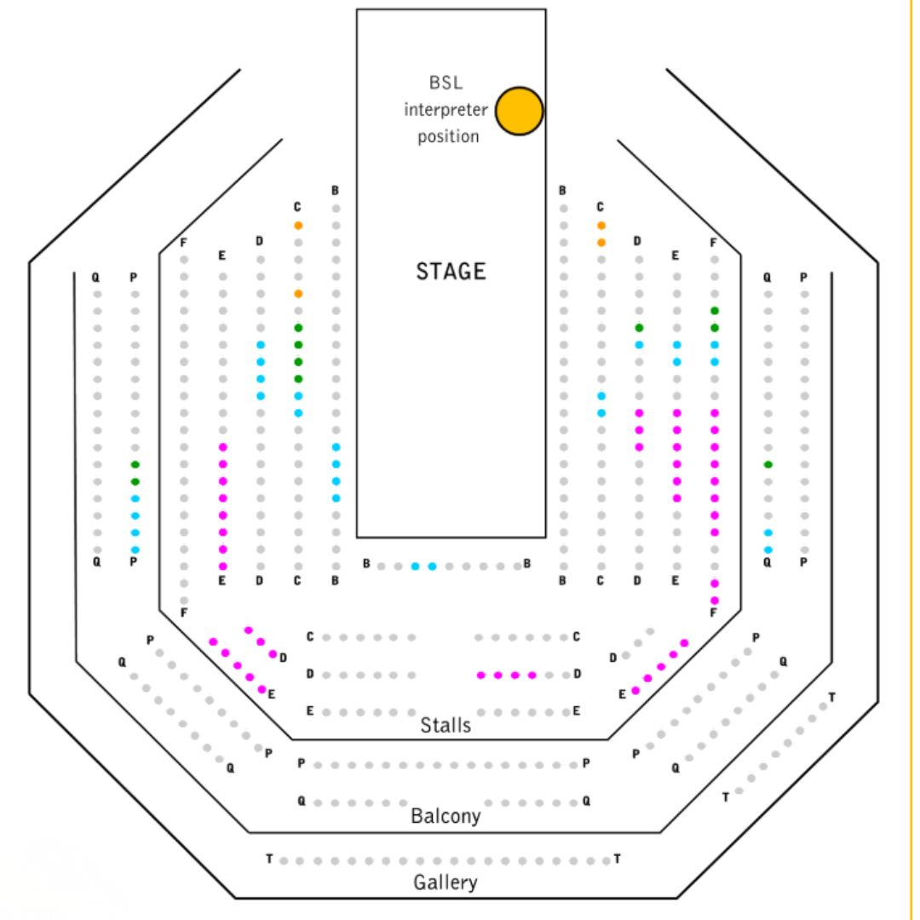

This show will take place in our main auditorium, which is the larger of our three performance spaces.
For this performance, the space will be in “thrust”” arrangement, meaning there will be seats on threes sides of the auditorium facing the stage.
Access to the main auditorium is via the downstairs doors (rows B - F), upstairs (rows P & Q). Row T is in the gallery also accessible via the upstairs doors. Our ushers are on hand to help you; they wear black t-shirts and jumpers with usher or head usher on the backs.
If you have an e-ticket, please arrive at the Young Vic with your ticket ready on your phone. You could also print your ticket in advance of your visit, or you can collect your ticket from our Box Office.
Please click here to see a sensory map of the building.

Facilities
There are toilets located on the ground and first floor at the Young Vic, via The Cut Bar. We have ladies and gents toilets on the ground floor and gender-neutral toilets on the first floor, as well as accessible/baby changing toilets. Sanitary bins are available in all facilities.

Building Accessibility
All indoor venues are accessible with lifts & ramps.

Assistance Dogs
Assistance dogs are welcome at the Young Vic. If you are planning a visit, please let us know in advance which performance you will be attending by calling our Box Office on 020 7922 2922 or e-mailing boxoffice@youngvic.org. Please note your assistance dog will need to accompany you into the auditorium.

Access for all
For full information about our access measures, please visit our Access for all page, on our website here: www.youngvic.org/visit-us/access-for-all

Synopsis

The play is set in 1938 Brooklyn, New York

ACT ONE

Scene 1
(Actor smoking on stage)
We see Phillip Gellburg (Eli Gelb) waiting in the home office of Dr. Harry Hyman (Alex Waldmann), dressed in black. Margaret Hyman (Nancy Carroll), the doctor’s wife, talks with him and we discover Gellburg’s wife, Sylvia, is unwell.
When Dr. Hyman enters, the tone shifts to clinical seriousness. Hyman explains that specialists can find no physical cause for Sylvia’s (Pearl Chanda) paralysis and believes it to be psychological—an “hysterical paralysis” brought on by fear or deep emotional conflict. Gellburg struggles to accept that Sylvia’s condition could be mental rather than physical and bristles at personal questions about their marriage.
As they talk, Gellburg reveals his intense attachment to Sylvia, his terror at her collapse, and his simmering anxieties about antisemitism and the rise of Hitler in Europe.
Hyman suggests that Sylvia may be using her illness as a form of protest or expression of hidden conflict, even directed at Gellburg himself. This idea deeply unsettles him.
Hyman urges Gellburg to respond with patience and love rather than anger, insisting that illness never happens in isolation but within relationships. Gellburg leaves shaken, confused, and fearful that his marriage may be at the centre of Sylvia’s mysterious condition.

Scene2
In the Gellburg bedroom, Sylvia sits reading the newspaper reports of Nazi brutality in Germany. Her sister Harriet (Juliet Cowan) urges her to eat, clearly alarmed by Sylvia’s physical condition and by her obsessive focus on the news. Sylvia explains her horror at particular events including making old men scrub the pavement with a toothbrush.
Sylvia describes a deep, aching sensation throughout her body.
After Harriet leaves, Phillip enters, awkwardly affectionate and carrying a jar of sour pickles. He tries to be practical and reassuring, mentioning work, their son Jerome’s success at the Army. Sylvia is distant and ironic about Jerome’s military career, and Phillip grows frustrated by what he sees as her passivity and withdrawal.
Phillip reveals that Dr. Hyman believes Sylvia’s paralysis may be psychological rather than physical. Sylvia resents the suggestion, insisting that she is truly numb.
Phillip awkwardly attempts emotional intimacy. He tells Sylvia he loves her and begs her to get better, offering vague promises of change. Their conversation turns raw and bitter as long-suppressed grievances about their marriage surface: regret, emotional distance, and years of unresolved pain. Sylvia accuses Phillip of only wanting to talk now that she is broken and aging; Phillip insists he wants her to stand up.
In a desperate attempt to prove she can walk; Phillip lifts Sylvia up and urges her to stand. When he releases her, she collapses to the floor. He kneels over her, angry and terrified, demanding to know what she is trying to do, while Sylvia stares at him.
Scene 3
Dr. Hyman’s office. He is in riding clothes. Harriet tells Dr. Hyman how much she appreciates that Sylvia is in good hands. They discuss about how the news in Germany is affecting Sylvia and the history of the relationship between Phillip and Sylvia, as well as Dr. Hyman’s own history of being much admired by women in their younger years.
Scene 4
Stanton Case (Nigel Whitmey), Phillip’s boss is getting ready to leave his office as Phillip enters. Stanton tells Phillips that he wants to talk about a mortgage case they are working on. Phillips explains the situation to Stanton and what he thinks of the property and his prediction.
Scene 5
Sudden change in lighting
Dr. Hyman came in to see Sylvia privately. He interviews Sylvia. She talks about her loneliness, her sense of being unwanted, her feeling that her life has passed without being truly lived.
From this conversation, Dr. Hyman begins to believe that Sylvia’s paralysis is not the fear of what’s happening to Jewish people in Germany or on the news. It is the fear of powerlessness, abandonment, and invisibility. These may be the causes of her unable to move her legs.
Scene 6
An actor smokes in this scene. Sudden change in lighting.
We are now in Hyman’s office. Phillip is seated. Margaret enters with a cup of cocoa . She hands the cup of cocoa to Phillip.
Phillip tells Dr. Hyman that he has decided to do what was suggested. As the conversation goes on, Phillip starts wondering whether Sylvia’s paralysis is real.
But as the conversation deepens and gets more intense, Phillip reveals his lifelong insecurity, his shame over his appearance, his terror of seeming weak. He admits he has always felt like an impostor.
Towards the end of the conversation, Phillips questions Dr. Hyman about what was said in his meeting with Sylvia and gets upset by his own assumption. He leaves anger.
Margaret comes in saying that Dr. Hyman himself gets involved with Sylvia too deeply, suggesting having someone else see her.
Scene 7
Phillip comes to Stanton Case’s office to apologise for the firm losing the 611 Broadway building to Allen Kershowitz. Case is distant and cold, clearly disappointed and suspicious. As their conversation unfolds, Case reveals that the information Phillip had given him about Wanamaker’s leaving the neighbourhood was false, and that Kershowitz appears to have outbid them with full confidence in the building’s value.
Phillip grows nervous and defensive, trying to convince Case of his loyalty and insisting he had nothing to do with Kershowitz’s purchase. Case’s restrained, cutting manner makes it seem as though he suspects Phillip of double-dealing, though he never directly accuses him.
The tension escalates as Phillip desperately tries to explain himself, only to become more confused and incoherent. Case finally loses patience and storms out, leaving Phillip alone in shock, realizing that his standing and security at the firm are in danger.
Scene 8
Contain smoking in this scene
Sylvia is in bed reading a newspaper. Hyman appears. He comes and shakes hands.
Dr. Hyman tells her that her illness is psychological and that she needs proper therapy. Sylvia resists this, clinging to Hyman. She explains to him that she has a recurring nightmare which she is chased by Germans, assaulted, and mutilated by a man whose face turns into her husband Phillip’s.
Dr. Hyman questions her about her marriage, revealing that Phillip has claimed they recently had sexual relations. Sylvia insists this is a lie and admits that she and Phillip have not slept together in nearly twenty years. Their marriage collapsed after Phillip became impotent and emotionally withdrawn following the birth of their son.
As the conversation turns to the rise of Nazi violence against Jewish community, Sylvia’s anxiety goes into hysteria. In a panic, she tries to stand and collapses.
Phillip enters as Dr. Hyman revives her. After Dr. Hyman leaves, Sylvia briefly believes she is regaining strength but then confronts Phillip about lying to Dr. Hyman and about their marriage. Phillip breaks down and admits his shame, jealousy, and feelings of inferiority, confessing that her independence and ambition destroyed his sense of masculinity.
Sylvia realizes she has sacrificed her entire life to protect Phillip’s pride. She rejects him sexually and emotionally. Phillip collapses in despair, begging her not to abandon him.
Scene 9
This scene contains sudden loud and prolonged noise and moments of complete darkness.
Phillip comes to Case’s office to defend himself after a business deal has gone wrong. Case is distant and formal, making it clear that he has lost confidence in Phillip over the failed Wanamaker’s building transaction. Philip insists his actions were loyal and meant to protect the company, but Case remains noncommittal and cold.
Growing desperate, Philip tries to reassure Case of his loyalty and denies any connection with a man named Allen Kershowitz, whom Case apparently suspects of being involved in wrongdoing. As the pressure mounts, Philip explodes emotionally, blurting out a bitter, self-loathing remark that suggests he is being suspected because he is Jewish.
Case is shocked and offended by the comment. Humiliated, shaken, and overwhelmed, Phillip tries to leave but collapses, clutching his chest and struggling to breathe. Case panics and rushes out to call for a doctor. Phillip falls to the floor. The other characters remain on stage laughing at Phillip as he pulls out a toothbrush and begins to scrub the floor.
Scene 10
Sylvia sits in her bedroom, besides here are Margaret and her sister Harriet, drinking cocoa while they discuss Phillip’s recent heart attack and his early release from the hospital.
Sylvia believes Phillip insisted on coming home because he wants to die there and because he wants to confront her. She reflects bitterly on how people live as though they will last forever, only to be reminded of their fragility.
As the conversation turns more personal, Sylvia blames herself for Phillip’s collapse.
Harriet passionately rejects Sylvia’s self-blame and insists she has been a devoted wife, then leaves, overwhelmed with emotion.
Margaret stays behind and offers a philosophical reflection. Sylvia listens, wishing her life had turned out differently.
Scene 11
Phillip lies in bed recovering from his heart attack while Hyman examines him. Dr. Hyman insists Phillip should be in the hospital, but Phillip refuses to leave home or Sylvia. Now he is overwhelmed by fear, regret, and the sense that his life is closing in on him: he has lost his job, his dignity, and possibly his wife.
Phillip pours out his bitterness over his treatment at Brooklyn Guarantee and his humiliation at being suspected of betrayal. His anger spills into self-hatred and obsession with being Jewish in a hostile world. He confesses his lifelong insecurity, his worship of Sylvia, and his terror that she is now afraid of him.
Phillip begs Hyman to help him get Sylvia back. Dr. Hyman leaves Phillip alone to face himself.
Sylvia and Phillip speak quietly and painfully. Phillip apologises for the life of fear he imposed on her, admitting that he lived in constant terror of persecution and disaster. Sylvia confesses that she feels trapped in a life that no longer belongs to her and in a body that has failed her. Each blame themselves for the other’s suffering.
As Phillip’s condition suddenly worsens, Sylvia panics. In a desperate attempt to reach him, she forces herself out of her chair, and for the first time, stands.

