**Pre-Show Information**   
  
***An Oak Tree***

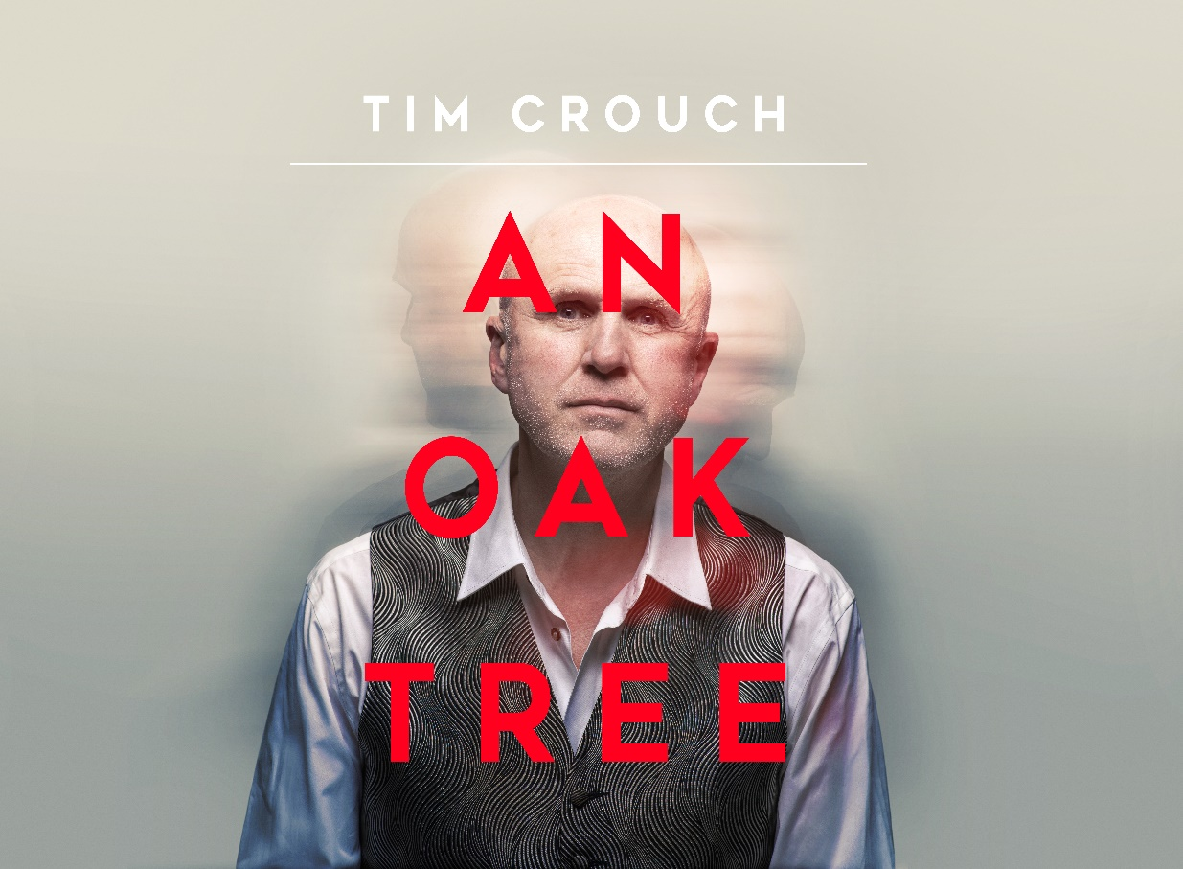

Written and Directed by Tim Crouch

**Contents**

**Page 2:** Introduction

**Page 3:** Show information, including running time and content warnings

**Pages 4- 5:** The auditorium, including access information

**Pages 6-9:** Show summary

**Introduction:**

This document contains detailed information about the show in order to describe what you should expect when attending.

This includes information about the content warnings, plot, space, lighting and sound, audience participation, and further access information.

All of the information in this document was correct at the time of publishing.

More information will be available closer to the time of performance.

**Please note** that by discussing the content of the show, **the below information will contain key plot points and descriptions of what happens in the performance.**

**If you would like to receive elements of this information but avoid these spoilers, please do not read the section at the end of this document entitled ‘Show Synopsis’.**

**If you have any questions, please do not hesitate to contact our Box Office team:**

**E-mail:** [**boxoffice@youngvic.org**](mailto:%20boxoffice@youngvic.org)

**Phone number: 020 7922 2922**

**Show Information:**

**Running Time:** 1 hour and 20 minutes

**Content warnings:**

* Death of a family member / child
* Grief
* Strong language
* Discussions of suicide

**Production warnings:**

* Moments of sudden loud music throughout

**The Auditorium**

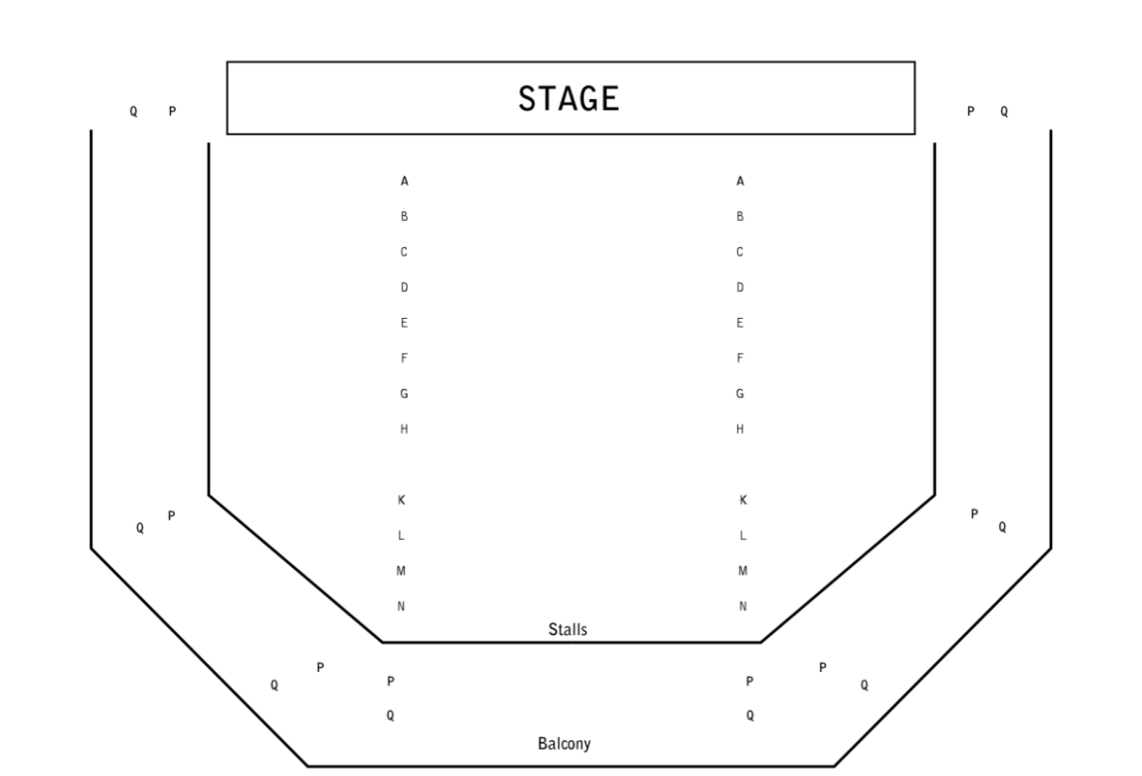

***An Oak Tree***

This show will take place in our main auditorium, which is the larger of our three performance spaces.

For this performance, the space will be in an “end on” arrangement, meaning there will be seats on one side of the auditorium facing the stage.

Access to the main auditorium is via the upstairs doors (rows K - Q) and downstairs (rows A – J) via the main doors. Rows S & T are in the gallery also accessible via the upstairs doors. Our ushers are on hand to help you, they wear red t-shirts and jumpers with our logo.

Please arrive at the Young Vic with your ticket ready on your phone. You could also print your ticket in advance of your visit, or you can collect your ticket from our Box Office.

**Facilities:**

There are toilets located on the ground and first floor at the Young Vic, via The Cut Bar. We have gender-neutral and accessible/baby changing toilets. Sanitary bins are available in all.

**Building Accessibility:**

All indoor venues are accessible with lifts & ramps and toilets provided.

**Assistance Dogs:**

Assistance dogs are always welcome at the Young Vic, if you are planning a visit, please let us know in advance which performance you will be attending by calling our Box Office on **020 7922 2922** or e-mailing [boxoffice@youngvic.org](mailto:%20boxoffice@youngvic.org) and we will be happy to look after your dog during the show.

**Access for all:**

For full information about our access measures, please visit our Access For All page, on our website here: [www.youngvic.org/visit-us/access-for-all](http://www.youngvic.org/visit-us/access-for-all)

**Show Synopsis:**

**Potentially distressing themes**

**Sound cues**

**Lighting cues**

Hello. This is Tim Crouch, writer of and one of the actors in *An Oak Tree*.

This is a tricky play to describe. First thing to know is that *An Oak Tree* is not an improvised play. Every word spoken by the actors in this play has been scripted. *An Oak Tree* is different in performance every time, but the words remain the same.

The play has two actors. One of them is me. I know the play. The second actor meets me an hour before the show. This second actor has neither seen nor read a word of the play they’re about to be in. This actor sits in a reserved seat on the front row when the play begins.

When the play begins, I walk on stage, introduce myself, and then invite the second actor in the audience onstage with me. I introduce the second actor to the audience and explain the situation. I hand the second actor a page of text and we play a short scene. I then tell the story of the play which is as follows. The second actor will play a man called Andy Smith, the Father of a child who was killed by a car. I will play the man who was driving that car. My character is a stage Hypnotist. The Father Andy Smith will volunteer for the Hypnotist’s act, but I won’t recognise him as three months have passed since the accident. I then asks the second actor to return to their seat in the audience.

**Loud music plays.** I set out eight chairs across the stage with a piano stool in the middle of the row. I then start a stage hypnotist’s act and ask for volunteers. The second actor volunteers out of their seat in the audience. I give instructions to the second actor directly and sometimes through an earpiece that they wear.

Just as the Hypnotist’s act is established, the action changes to a roadside – this is the location of the fatal accident. **There is the sound of traffic passing.** I explain this location and its significance in the story to the second actor. The second actor’s character Andy has come to visit the site of the accident early in the morning, and Andy’s wife Dawn will arrive soon to take him home.

Just as this location is established, the play switches back to the Hypnotist’s act. Through my instructions, I get the second actor to play a range of different characters who have also volunteered for the act – Amanda, Richard, Keith, Jackie, etc. This is a very playful and fast-moving sequence which switches between the Hypnotist’s act and the roadside. The Hypnotist’s act begins with tests of suggestibility including asking the volunteers to play an imaginary piano. Only the Father Andy plays – and can’t stop playing.  There is an understanding that the Hypnotist is unable to hypnotise anyone, apart from the Father who responds to every suggestion. These sequences move fast and gradually all the imaginary volunteers return to their seats until only the Father is left. The Father does everything the Hypnotist asks him to do. The Hypnotist thinks that the Father is there to sabotage his act. He punishes the Father by hypnotising him to believe that he’s naked, that he’s soiled himself and that he’s killed a child. The Father is devastated and from this moment comes a revelation for the Hypnotist of who the Father actually is.

The scene changes. **A piano plays a faltering rendition of Bach’s Goldberg Variations – as if played by a child.** The piano in *An Oak Tree* represents Andy’s daughter who was on her way to a piano lesson when she was killed.

The second actor and I stand side by side and we both read from scripts that describe the night of the accident from the points of view of our characters the Father and the Hypnotist. This text is delivered out to the audience. For the Hypnotist, all the memories of that night are in black and white. For the Father, on the night of his daughter’s death, everything becomes abstract blocks of colour.

*An Oak Tree* is as much about my relationship with the second actor as it is about the Father and the Hypnotist. There are parallels throughout. The Father has volunteered for the Hypnotist’s act; the second actor has volunteered for my show. Lines spoken contain the possibility of both these interpretations.

A scene begins where the second actor reads from a script I have given them. When the Hypnotist realises who Andy Smith is (the Father of the girl who was killed by his car) his attitude changes. He offers to help but the Father is still stuck in the hypnotised belief that he’s naked, dirty and responsible for a child’s death. The Hypnotist uses suggestion to clean him, clothe him and attempt to de-hypnotise him. The Father explains how he saw a poster for the Hypnotist’s act and thought the Hypnotist could help him. **The Father’s life and relationship with his wife is falling apart and he needs help.**

I feed a speech into the earpiece of second actor which they in turn deliver to the audience. The speech describes the events after Andy’s daughter’s death. In this speech, we understand that the Father has turned a tree next to where she died, into his daughter. She is more present to him in the form of that tree than when she was alive.

A scene plays that is both me asking the second actor how they’re doing and simultaneously the Hypnotist asking the Father how they’re doing. The play regularly operates on these two levels, with the two actors being both themselves and the characters. **This scene ranges over what the audience has learnt so far and ends with a statement from the Father that he is suicidal and needs help.**

**Loud music plays.** The second actor and I sit back-to-back. In this sequence I play Andy Smith’s wife, Dawn. It’s late at night. Andy reads a self-help text underscored by music while Dawn berates her husband for not being able to see the reality of their loss. The two speeches play over each other and culminate in Dawn’s fury and despair.

A scene which once again plays on the duality of actor and character. The Hypnotist tells the Father how well they’re doing (I tell the second actor how well they’re doing). It’s the same scene offering two interpretations. The second actor reads from their script that they want to stop. The Hypnotist explains how the girl’s death was not his fault. The Father’s response is to say how proud he is of his own piano playing abilities. He is clearly still hypnotised from the Hypnotist’s show, believing he can play the piano.

The action switches to the roadside. Dawn has arrived to take her husband home. She has brought their youngest daughter with her, Marcia. In this scene, Dawn is represented by me; Marcia is represented by a chair; the tree is represented by a piano stool; the road is represented by the stage. And Andy is represented by the second actor who doesn’t know the play. Once again, Dawn urges Andy to see things for what they really are. Andy insists that the tree is really their daughter.

The next scene between me and the second actor is about the experience of being in the play – but also a conversation between the Hypnotist and the Father. The Father wishes he could have said goodbye to his daughter. He didn’t go to the morgue. The Hypnotist again attempts to de-hypnotise the Father. He says that there wasn’t a piano. There was never a piano. No, says the Father/Second Actor, I really played it.

**Loud music plays.**

I stand side by side with the second actor and we both read scripts out to the audience. **Our speeches are underscored by piano playing.** The text is a recreation of the moment of the child’s death. The colour of the sky; the child walking; the Hypnotist driving; the child listening to music; the Hypnotist taking his eye of the road; the child stepping out; a car. These speeches offer an opportunity for the Father to finally say goodbye to his daughter. And to be free again. **As the text ends, the piano plays forcefully and freely.**

**There’s a black out.** The play ends.

If you would like any further clarification or have any questions, please do get in touch with our Box Office team.   
  
Email: [**boxoffice@youngvic.org**](mailto:%20boxoffice@youngvic.org)  
Phone number: **020 7922 2922**   
  
See you soon!   
  
**Welcome Team**