Pre-Show Information
Broken Glass

Written by Arthur Miller
Directed by Jordan Fein
Contents
Page 2: Introduction
Page 3: Show information, including running time and content warnings
Pages 4 - 5: The auditorium, including access information

Introduction:
This document contains detailed information about the show in order to describe what you should expect when attending.
This includes information about the content warnings, plot, space, lighting and sound, audience participation, and further access information.
All of the information in this document was correct at the time of publishing.
More information will be available closer to the time of performance.
Please note that by discussing the content of the show, the below information will contain key plot points and descriptions of what happens in the performance.
If you would like to receive elements of this information but avoid these spoilers, please do not read the section at the end of this document entitled ‘Show Synopsis’.
If you have any questions, please do not hesitate to contact our Box Office team:
E-mail: boxoffice@youngvic.org
Phone number: 020 7922 2922

Show Information:

Running Time: TBC (this will be provided closer to the show dates)
Content warnings:
- Racism, particularly antisemitism, and references to Nazism
- Sexism
- Ablism and discriminatory attitudes to disability
- Domestic violence/ abuse
- Sexual content, including descriptions of sexual assault
- Struggles with poor mental and physical health, including characters collapsing onstage
Production Warnings:
- These will be provided closer to the show dates

The Auditorium

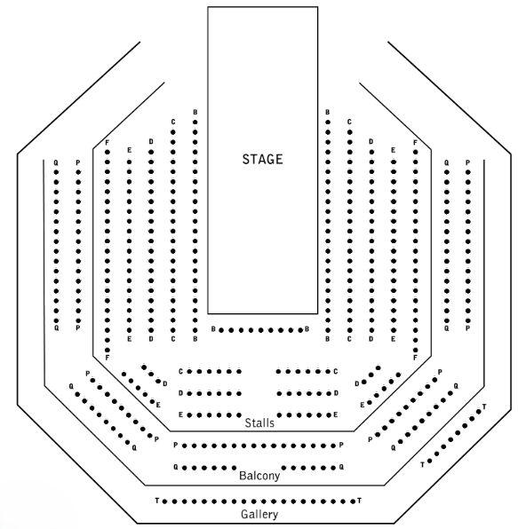

Broken Glass
This show will take place in our main auditorium, which is the larger of our three performance spaces.
For this performance, the space will be in a “Thrust” arrangement, meaning there will be seats on three sides of the auditorium facing the stage.
Access to the main auditorium is via the upstairs doors (rows P - Q) and downstairs (rows B - F) via the main doors. Row T is in the gallery and also accessible via the upstairs doors. Our ushers are on hand to help you, they wear black t-shirts which say “Usher” on the back.
Please arrive at the Young Vic with your ticket ready on your phone. You could also print your ticket in advance of your visit, or you can collect your ticket from our Box Office.
Please click here to see a sensory map of the building.

Facilities:
There are toilets located on the ground and first floor at the Young Vic, via The Cut Bar. We have ladies and gents toilets on the ground floor and gender-neutral toilets on the first floor, as well as accessible/baby changing toilets. Sanitary bins are available in all facilities.
Building Accessibility:
All indoor venues are accessible with lifts & ramps.
Assistance Dogs:
Assistance dogs are welcome at the Young Vic. If you are planning a visit, please let us know in advance which performance you will be attending by calling our Box Office on 020 7922 2922 or e-mailing boxoffice@youngvic.org. Please note your assistance dog will need to accompany you into the auditorium.
Access for all:
For full information about our access measures, please visit our Access for all page, on our website here: www.youngvic.org/visit-us/access-for-all

Show Synopsis:
This will be available closer to the show dates
If you would like any further clarification or have any questions, please do get in touch with our Box Office team.
Email: boxoffice@youngvic.org
Phone number: 020 7922 2922
See you soon!
Welcome Team

