**Pre-Show Information**   
  
***Entertaining Mr Sloane***



Written by **Joe Orton**

Directed by **Nadia Fall**

**Contents**

**Page 2:** Introduction

**Page 3:** Show information, including running time and content warnings

**Pages 4 - 6:** The auditorium, including access information

**Introduction:**

This document contains detailed information about the show in order to describe what you should expect when attending.

This includes information about the content warnings, plot, space, lighting and sound, audience participation, and further access information.

All of the information in this document was correct at the time of publishing.

More information will be available closer to the time of performance.

**Please note** that by discussing the content of the show, **the below information will contain key plot points and descriptions of what happens in the performance.**

**If you would like to receive elements of this information but avoid these spoilers, please do not read the section at the end of this document entitled ‘Show Synopsis’.**

**If you have any questions, please do not hesitate to contact our Box Office team:**

**E-mail:** [**boxoffice@youngvic.org**](mailto:%20boxoffice@youngvic.org)

**Phone number: 020 7922 2922**

**Show Information:**

**Running Time:** 2 hours 30 minutes including a 20-minute interval

**Content warnings:**

* Discussion of giving up a child
* Discussion of suicide
* Sexual content / nudity
* Themes of homophobia
* Themes of sexism
* Themes of racism
* Discussion of rape
* Elder abuse/ violence and injury
* Murder
* Brief mention of antisemitism

**Production warnings:**

* Herbal e-cigarettes

**The Auditorium**

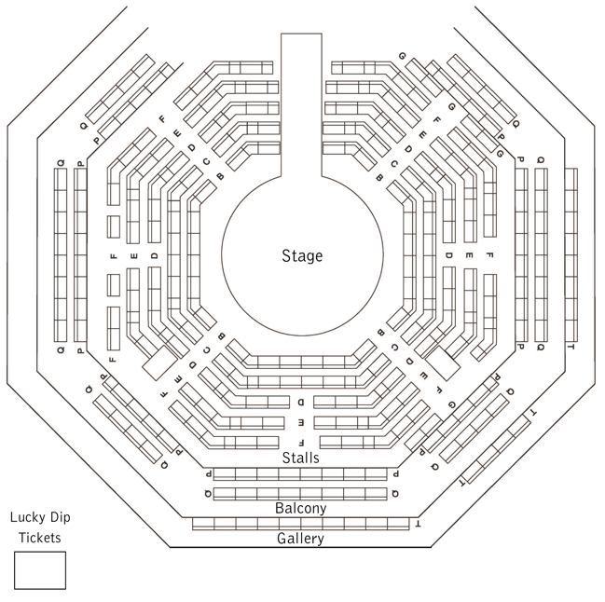

***Entertaining Mr Sloane***

This show will take place in our main auditorium, which is the larger of our three performance spaces.

For this performance, the space will be in an “in the round” arrangement, meaning there will be seats on all sides of the auditorium facing the stage.

Access to the main auditorium is via the upstairs doors (rows K - Q) and downstairs (rows A – J) via the main doors. Rows S & T are in the gallery also accessible via the upstairs doors. Our ushers are on hand to help you, they wear red t-shirts and jumpers with our logo.

Please arrive at the Young Vic with your ticket ready on your phone. You could also print your ticket in advance of your visit, or you can collect your ticket from our Box Office.

[Please click here to see a sensory map of the building.](https://www.youngvic.org/sites/default/files/attachments/Young%20Vic%20Sensory%20Map.pdf)

**Facilities:**

There are toilets located on the ground and first floor at the Young Vic, via The Cut Bar. We have ladies and gents toilets on the ground floor and gender-neutral toilets on the first floor, as well as accessible/baby changing toilets. Sanitary bins are available in all facilities.

**Building Accessibility:**

All indoor venues are accessible with lifts & ramps.

**Assistance Dogs:**

Assistance dogs are welcome at the Young Vic. If you are planning a visit, please let us know in advance which performance you will be attending by calling our Box Office on **020 7922 2922** or e-mailing [boxoffice@youngvic.org.](mailto:%20boxoffice@youngvic.org)Please note your assistance dog will need to accompany you into the auditorium.

**Access for all:**

For full information about our access measures, please visit our Access for all page, on our website here: [**www.youngvic.org/visit-us/access-for-all**](http://www.youngvic.org/visit-us/access-for-all)

**Show Synopsis:**

Potentially upsetting content

Act I:

When audiences walk into the auditorium, they will see a stage with the audience all around it. Pieces of furniture will be positioned beneath the stage and suspended from the ceiling.

The play opens in a rundown house near a rubbish dump, where Kath (**Tamzin Outhwaite**), a lonely middle-aged woman, lives with her elderly and infirm father, Kemp or "Dadda"(**Christopher Fairbank**).

Kath meets Mr. Sloane (**Jordan Stephens**), a charming young man looking for lodgings. Kath offers Sloane a room in the house and quickly becomes close and flirtatious with him. She reveals that she had a child out of wedlock and was forced to give it up by her family, leaving her nowhere to direct her maternal instincts.

Kemp, Kath's father, is suspicious of Sloane. He believes he recognizes him from the past as someone involved in a violent crime. Sloane, however, brushes it off.

Kath’s authoritative brother Ed (**Daniel Cerqueira**) arrives. While Ed is initially wary of Sloane, it quickly becomes clear that he is also romantically interested in him, and Ed’s closeted homosexuality is a point of tension between him and his father.

The act ends with Kath seducing Sloane into sleeping with her.

Act II:

Kath continues to dote on Sloane, increasingly possessive and emotionally erratic. She presents him with gifts in an effort to control him. Ed, a seemingly more respectable man with a veneer of morality, tries to mold Sloane into a sort of chauffeur/companion, offering him a better life, but clearly with sexual undertones to his interest. Sloane meanwhile has begun to take more liberties with the siblings, taking Ed’s car for joyrides and using it to entertain multiple women.

Kemp continues to voice his distrust of Sloane, insisting he is a criminal. Eventually, Sloane murders Kemp to silence him, beating him to death with a cane.

When Kath and Ed discover the body, they are horrified but quickly realize the scandal and inconvenience the truth would bring to their lives.

Instead of going to the police, both siblings conspire to cover up the crime, each hoping to keep Sloane under their influence.

Act III:

Tensions between Ed and Kath escalate as they try to negotiate an arrangement with Sloane for control over him.

Kath claims she is pregnant by Sloane and wants him to marry her.

Ed, meanwhile, offers Sloane protection and employment, subtly suggesting that a life with him would be more beneficial.

The three engage in a darkly comedic negotiation of terms, treating Sloane like an asset rather than a person, while Sloane himself tries to play both sides.

In the end, a compromise is reached: Sloane will alternate between living with Ed and Kath in a bizarre shared custody arrangement.

If you would like any further clarification or have any questions, please do get in touch with our Box Office team.   
  
Email: [**boxoffice@youngvic.org**](mailto:%20boxoffice@youngvic.org)  
Phone number: **020 7922 2922**   
  
See you soon!   
  
**Welcome Team**