# Pre-Show Information

## *Entertaining Mr Sloane*



Written by **Joe Orton**

Directed by **Nadia Fall**

# Contents

**Page 2:** Introduction

**Page 3:** Show information, including running time and content warnings

**Pages 4 - 6:** The auditorium, including access information

# Introduction:

This document contains detailed information about the show in order to describe what you should expect when attending.

This includes information about the content warnings, plot, space, lighting and sound, audience participation, and further access information.

All of the information in this document was correct at the time of publishing. More information will be available closer to the time of performance.

**Please note** that by discussing the content of the show, **the below information will contain key plot points and descriptions of what happens in the performance.**

**If you would like to receive elements of this information but avoid these spoilers, please do not read the section at the end of this document entitled ‘Show Synopsis’.**

**If you have any questions, please do not hesitate to contact our Box Office team:**

**E-mail:** [**boxoffice@youngvic.org**](mailto:%20boxoffice@youngvic.org) **Phone number: 020 7922 2922**

**Show Information:**

**Running Time:** TBC (this will be provided closer to the show dates)

# Content warnings:

* Discussion of death of a child / giving up a child
* Discussion of suicide
* Sexual content
* Themes of homophobia
* Themes of sexism
* Themes of racism
* Discussion of rape
* Elder abuse/ violence
* Murder
* Brief mention of antisemitism

# Production warnings:

* These will be provided closer to the show dates

# The Auditorium

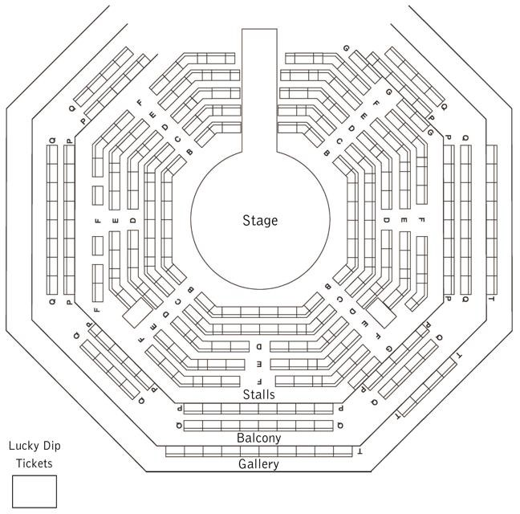

## *Entertaining Mr Sloane*

This show will take place in our main auditorium, which is the larger of our three performance spaces.

For this performance, the space will be in an “in the round” arrangement,

meaning there will be seats on all sides of the auditorium facing the stage.

Access to the main auditorium is via the upstairs doors (rows K - Q) and downstairs (rows A – J) via the main doors. Rows S & T are in the gallery also accessible via the upstairs doors. Our ushers are on hand to help you, they wear red t-shirts and jumpers with our logo.

Please arrive at the Young Vic with your ticket ready on your phone. You could also print your ticket in advance of your visit, or you can collect your ticket from our Box Office.

[Please click here to see a sensory map of the building.](https://www.youngvic.org/sites/default/files/attachments/Young%20Vic%20Sensory%20Map.pdf)

# Facilities:

There are toilets located on the ground and first floor at the Young Vic, via The Cut Bar. We have ladies and gents toilets on the ground floor and gender-neutral toilets on the first floor, as well as accessible/baby changing toilets. Sanitary bins are available in all facilities.

# Building Accessibility:

All indoor venues are accessible with lifts & ramps.

# Assistance Dogs:

Assistance dogs are welcome at the Young Vic. If you are planning a visit, please let us know in advance which performance you will be attending by calling our Box Office on **020 7922 2922** or e-mailing [boxoffice@youngvic.org.](mailto:%20boxoffice@youngvic.org) Please note your assistance dog will need to accompany you into the auditorium.

# Access for all:

For full information about our access measures, please visit our Access for all page, on our website here: [**www.youngvic.org/visit-us/access-for-all**](http://www.youngvic.org/visit-us/access-for-all)

# Show Synopsis:

This will be available closer to the show dates

If you would like any further clarification or have any questions, please do get in touch with our Box Office team.

Email: [**boxoffice@youngvic.org**](mailto:%20boxoffice@youngvic.org)

Phone number: **020 7922 2922**

See you soon!

**Welcome Team**