**Pre-Show Information**   
  
***Entertaining Mr Sloane***

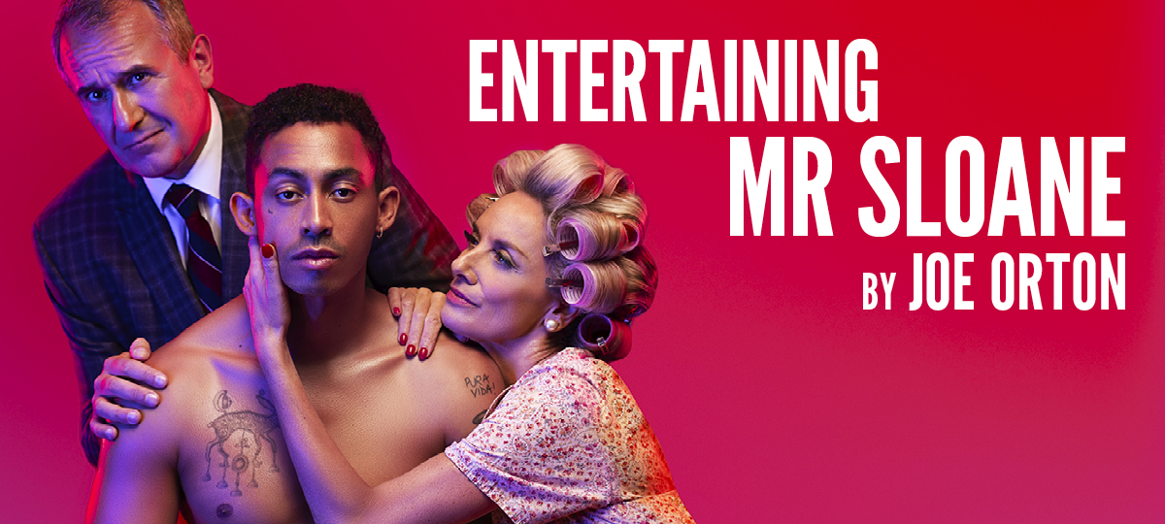

Written by **Joe Orton**

Directed by **Nadia Fall**

**Contents**

**Page 2:** Introduction

**Page 3:** Show information, including running time and content warnings

**Pages 4 - 5:** The auditorium, including access information

**Pages 6 – 7:** Show warnings with time stamps

**Pages 8 – 9:** Show synopsis

**Introduction:**

This document contains detailed information about the show in order to describe what you should expect when attending.

This includes information about the content warnings, plot, space, lighting and sound, audience participation, and further access information.

All of the information in this document was correct at the time of publishing.

More information will be available closer to the time of performance.

**Please note** that by discussing the content of the show, **the below information will contain key plot points and descriptions of what happens in the performance.**

**If you would like to receive elements of this information but avoid these spoilers, please do not read the section at the end of this document entitled ‘Show Synopsis’.**

**If you have any questions, please do not hesitate to contact our Box Office team:**

**E-mail:** [**boxoffice@youngvic.org**](mailto:%20boxoffice@youngvic.org)

**Phone number: 020 7922 2922**

**Show Information:**

**Running Time:** 2 hours 30 minutes including a 20-minute interval

**Content warnings:**

* Discussion of giving up a child
* Discussion of suicide
* Sexual content / nudity
* Themes of homophobia
* Themes of sexism
* Themes of racism
* Discussion of rape
* Elder abuse/ violence and injury
* Murder
* Brief mention of antisemitism

**Production warnings:**

* Herbal cigarettes
* Light sensitivity: Strobe lights (Duration: 3 minutes at the top of Act 2)
* Loud Music / Sound Effects
* Haze

**The Auditorium**

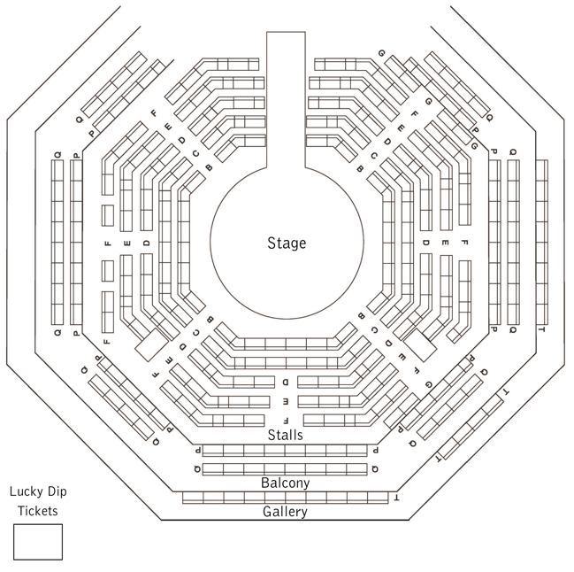

***Entertaining Mr Sloane***

This show will take place in our main auditorium, which is the larger of our three performance spaces.

For this performance, the space will be in an “in the round” arrangement, meaning there will be seats on all sides of the auditorium facing the stage.

Access to the main auditorium is via the upstairs doors (rows K - Q) and downstairs (rows A – J) via the main doors. Rows S & T are in the gallery also accessible via the upstairs doors. Our ushers are on hand to help you, they wear red t-shirts and jumpers with our logo.

Please arrive at the Young Vic with your ticket ready on your phone. You could also print your ticket in advance of your visit, or you can collect your ticket from our Box Office.

[Please click here to see a sensory map of the building.](https://www.youngvic.org/sites/default/files/attachments/Young%20Vic%20Sensory%20Map.pdf)

**Facilities:**

There are toilets located on the ground and first floor at the Young Vic, via The Cut Bar. We have ladies and gents toilets on the ground floor and gender-neutral toilets on the first floor, as well as accessible/baby changing toilets. Sanitary bins are available in all facilities.

**Building Accessibility:**

All indoor venues are accessible with lifts & ramps.

**Assistance Dogs:**

Assistance dogs are welcome at the Young Vic. If you are planning a visit, please let us know in advance which performance you will be attending by calling our Box Office on **020 7922 2922** or emailing [boxoffice@youngvic.org.](mailto:%20boxoffice@youngvic.org)Please note your assistance dog will need to accompany you into the auditorium.

**Access for all:**

For full information about our access measures, please visit our Access for all page, on our website here: [**www.youngvic.org/visit-us/access-for-all**](http://www.youngvic.org/visit-us/access-for-all)

**Show Warnings with Time Stamps:**

Pre-show- flickering lights

**Act 1: 45 minutes**

Opening: Lights up, music

1 minute: Sudden change of lighting state

5 minutes: Mention of suicide

12 minutes: Discussion of murder

15 minutes: Violence + Injury. (Character is stabbed in the leg with a fork – a fake wound created with makeup is then shown, but no blood)

17 – 20 minutes: Partial nudity – character removes their trousers

21 – 33: Cigarettes smoked on stage throughout - 2-3 cigarettes while character is on stage

42 minutes: Mention of rape

44 minutes: Nudity and scenes of a sexual nature – ends with a flicker of lights and loud music

**Act 2: 1 hour 17 minutes**

Opening: Loud music and strobe lights lasting for 3 minutes

8 minutes: Racism / Xenophobia

12 minutes: Smoking on stage - continues intermittently for 20 minutes

21 minutes: fat shaming

30 minutes: Injury – character shows fake injuries created with makeup

37 minutes: Smoking

44 minutes: Description of murder

45 minutes: flickering lights lasting for about 1 minute

46 minutes: Violence accompanied by flashing lights and loud music / sound effects

47 minutes: sudden blackout to end flashing lights

48 minutes: Smoking onstage – continues intermittently for following 15 mins

1:11: One character slaps another character – followed by a violent struggle

**Show Synopsis:**

Potentially upsetting content

Strobe Lighting + Loud Music

Act I:

When audiences walk into the auditorium, they will see a stage with the audience all around it. Pieces of furniture will be positioned beneath the stage and suspended from the ceiling.

The play takes place in a rundown house near a rubbish dump, where Kath (**Tamzin Outhwaite**), a lonely middle-aged woman, lives with her elderly father, Kemp or "Dadda"(**Christopher Fairbank**).

Kath meets Mr. Sloane (**Jordan Stephens**), a charming young man looking for lodgings. Kath offers Sloane a room in the house and quickly becomes flirtatious towards him. **She reveals that she had a child out of wedlock and was forced to give it up by her family, leaving her nowhere to direct her maternal instincts.**

Kath introduces Sloane to her father. Kemp is suspicious of Sloane, believing he recognizes him from the past as someone involved in a violent crime. **Sloane denies this and their exchange ends with Kemp stabbing Sloane in the leg with a fork.** Kath chastises Kemp and takes off Sloane’s trousers to bandage his leg.

Kath’s authoritative brother Ed (**Daniel Cerqueira**) arrives. While Ed is initially wary of Sloane, it quickly becomes evident that he is also romantically interested in him, and that Ed’s closeted homosexuality is a point of tension between him and his father who refuses to speak to him.

The act ends with Kath seducing Sloane into sleeping with her.

Act II:

**This act opens with loud music and intense strobe for the first 3 minutes.** Sloane has begun to take more liberties with the siblings, taking Ed’s car for joyrides and using it to entertain women. Kath continues to dote on Sloane, becoming increasingly possessive and excusing his poor behavior. She tells Sloane that she is pregnant with his child in an effort to persuade him to marry her. When Ed finds out, he is initially upset, but similarly excuses Sloane’s poor behavior, believing Sloane's story that Kath threw herself at him and he is not to blame. Ed seems determined to mold Sloane into a more moral person, offering him a job as a chauffeur/companion, but with clear sexual undertones to his interest. Sloane agrees in an effort to escape his obligations to Kath.

Kemp continues to voice his distrust of Sloane, insisting he is a criminal. **Eventually, Sloane murders Kemp to silence him, beating him to death with a cane. This scene is accompanied by flashing lights and loud music.**

When Kath and Ed discover the body, they are horrified but quickly realize the scandal and inconvenience the truth would bring to their lives.

Instead of going to the police, both siblings conspire to cover up the crime, each hoping to keep Sloane under their influence.

In the end, a compromise is reached: Sloane will alternate between living with Ed and Kath in a bizarre shared custody arrangement.

If you would like any further clarification or have any questions, please do get in touch with our Box Office team.   
  
Email: [**boxoffice@youngvic.org**](mailto:%20boxoffice@youngvic.org)  
Phone number: **020 7922 2922**   
  
See you soon!   
  
**Welcome Team**