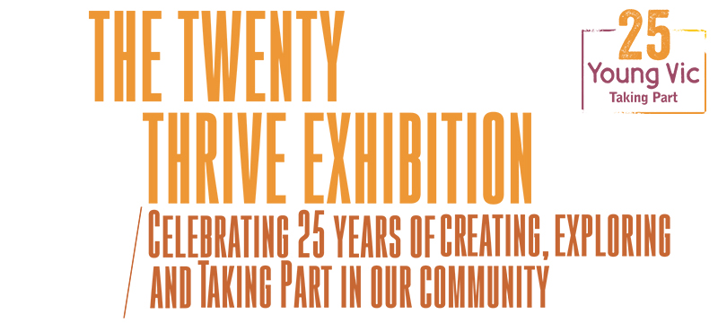
Pre-Exhibition Information

A Young Vic Taking Part Project
THE TWENTY THRIVE EXHIBITION
Celebrating 25 years of creating, exploring and Taking Part in our community

This document contains detailed information about the show in order to describe what you should expect when attending.
This includes information about the content warnings, the space, lighting and sound, audience participation, and further access information.
All of the information in this document was correct at the time of publishing. More information will be available closer to the time of the exhibition.

If you have any questions, please do not hesitate to contact our Box Office team:
E-mail: boxoffice@youngvic.org
Phone number: 020 7922 2922

The Auditorium

The Twenty Thrive Exhibition
This show will take place in The Maria Studio.
Access to the Maria Studio is via the downstairs. Our ushers are on hand to help you, they wear red t-shirts and jumpers with our logo.
Please arrive at the Young Vic with your ticket ready on your phone or have it printed before you enter or you can collect from box office.
Facilities:
There are toilets located on the ground and first floor at the Young Vic, via The Cut Bar. We have gender-neutral and disabled/baby changing toilets. Sanitary bins are available in all. All indoor venues will also be accessible with lifts & ramps and toilet provided.
Assistance Dogs:
Assistance dogs are always welcome at the Young Vic, if you are planning a visit please let us know in advance which performance you will be attending by calling our box office on 020 7922 2922 or e-mailing boxoffice@youngvic.org and we will be happy to look after your dog during the show.

Access for all:
For full information about or access measures, please visit our Access for all page, on our website here: www.youngvic.org/visit-us/access-for-all

Exhibition Information:

This exhibition involves walking around the space at your own pace and optional audience interaction. It contains changing lighting states and ambient sound. It includes references to ill mental health, the sex industry, homelessness and political struggle. It has one exhibit that includes minimal strong language which visitors do not have to engage with.

Lighting:
- Changing lighting states

Sound:
- Ambient sounds

More information will be available closer to the time.
If you would like any further clarification or have any questions, please do get in touch with our Box Office team.
Email: boxoffice@youngvic.org
Phone number: 020 7922 2922

See you soon!
Welcome Team

