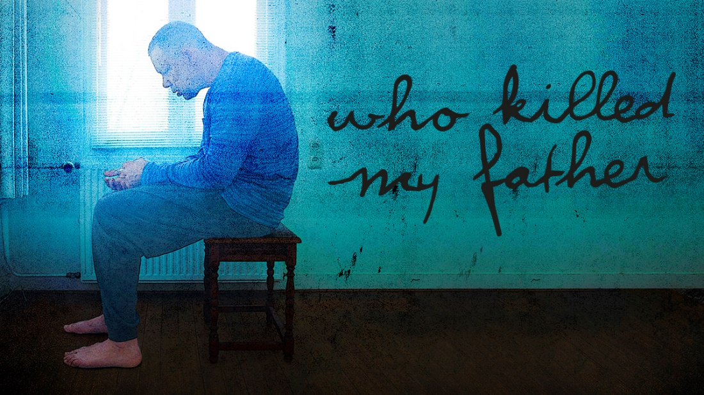
Pre-Show Information
An Internationaal Theater Amsterdam production in association with Young Vic
Adapted by Ivo van Hove
from the book by Édouard Louis
This document contains detailed information about the show in order to describe what you should expect when attending.
This includes information about the content warnings, plot, the space, lighting and sound, audience participation, and further access information.
All of the information in this document was correct at the time of publishing. More information will be available closer to the time of performance.
Please note that by discussing the content of the show, the below information will contain key plot points and descriptions of what happens in the performance.
If you would like to receive elements of this information but avoid these spoilers, please do not read the sections at the end of this document ‘Show Information’ and ‘Show Synopsis’.
If you have any questions, please do not hesitate to contact our Box Office team:
E-mail: boxoffice@youngvic.org
Phone number: 020 7922 2922

The Auditorium
Who Killed My Father
This show will take place in our main auditorium, which is the larger of our three performance spaces.
For this performance, the space will be in a ‘end on’ arrangement, meaning the seats are arranged on three sides of the stage (see below). The maximum capacity is 420.
Access to the main auditorium is via the upstairs (rows K – Q) and downstairs (rows A – J) via the main doors. Our ushers are on hand to help you, they wear red t-shirts and jumpers with our logo.
Please arrive at the Young Vic with your ticket ready on your phone or have it printed before you enter or you can collect from box office.
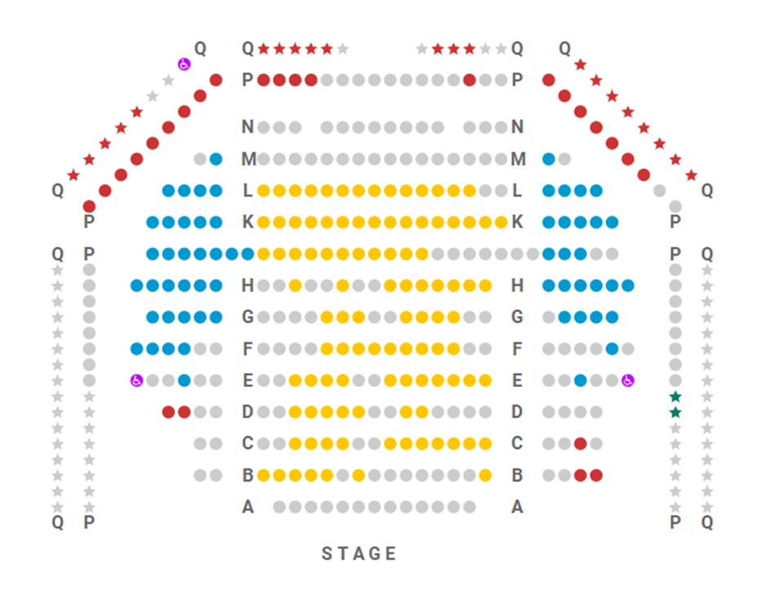

Facilities:
There are toilets located on the ground and first floor at the Young Vic, via The Cut Bar. We have gender-neutral and disabled/baby changing toilets. Sanitary bins are available in all. All indoor venues will also be accessible with lifts & ramps and toilet provided.
Assistance Dogs:
Assistance dogs are always welcome at the Young Vic, if you are planning a visit please let us know in advance which performance you will be attending by calling our box office on 020 7922 2922 or e-mailing boxoffice@youngvic.org and we will be happy to look after your dog during the show.

Access for all:
For full information about or access measures, please visit our Access for all page, on our website here: www.youngvic.org/visit-us/access-for-all
Show Information:
Content Warnings:
This production contains smoke, flashing lights and loud factory machinery effects. The show contains themes including alcoholism, domestic violence and homophobia. There are references to violent conduct, discrimination in contexts of class, social inequity and race.

Lighting:
- Smoke
- Haze
- TV screen
- Moment of bright flashing light
- Rotating disco lights
Sound:
- Loud music
- Sudden loud factory machinery noises
Stage:
- Lit cigarette
- Smells of oil and BBQ
- Discussions of alcoholism, domestic violence
- Strong language
- Disco ball
- Violent outburst (towards the end)

Show Synopsis:
Who Killed My Father follows a man who recounts his childhood – particularly the relationship with his father. We learn about a hardworking father who is abusive and violent. The father’s disdain for marginalised communities, such as gay men, has left a long-lasting mark on his gay son. At the same time, we learn about how abandoned France’s working class feel by the state, run by nameless politicians who are seemingly more interested in titles and the aesthetics of politics than social change.

More information will be available closer to the time of performance.
If you would like any further clarification or have any questions, please do get in touch with our Box Office team.
Email: boxoffice@youngvic.org
Phone number: 020 7922 2922

See you soon!
Welcome Team

